Class diagram – dinosaurs package

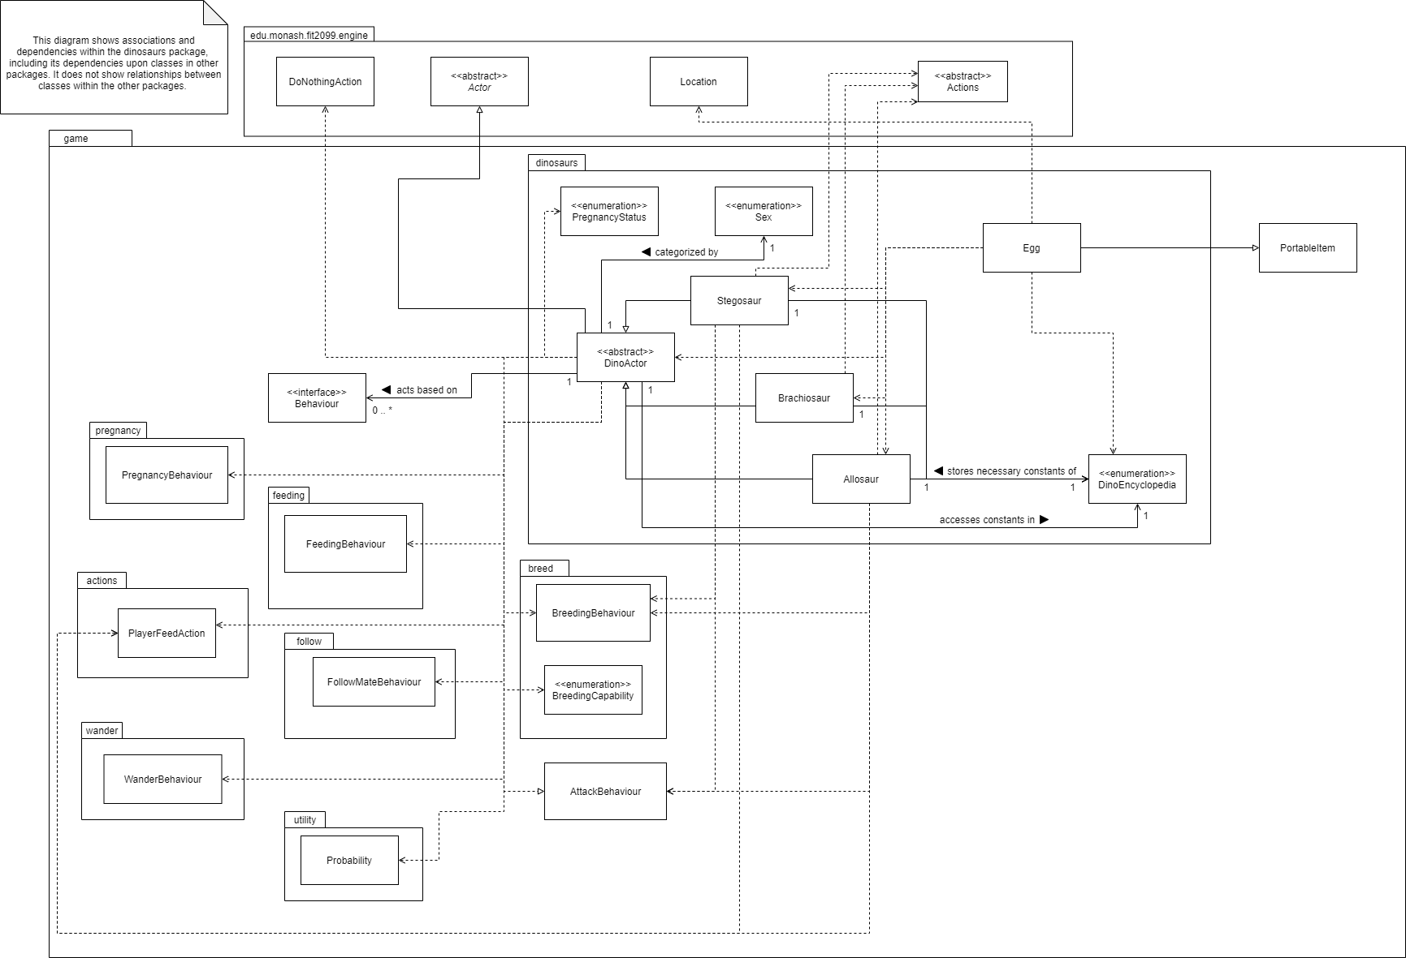

Class diagram – pregnancy, breed and follow packages

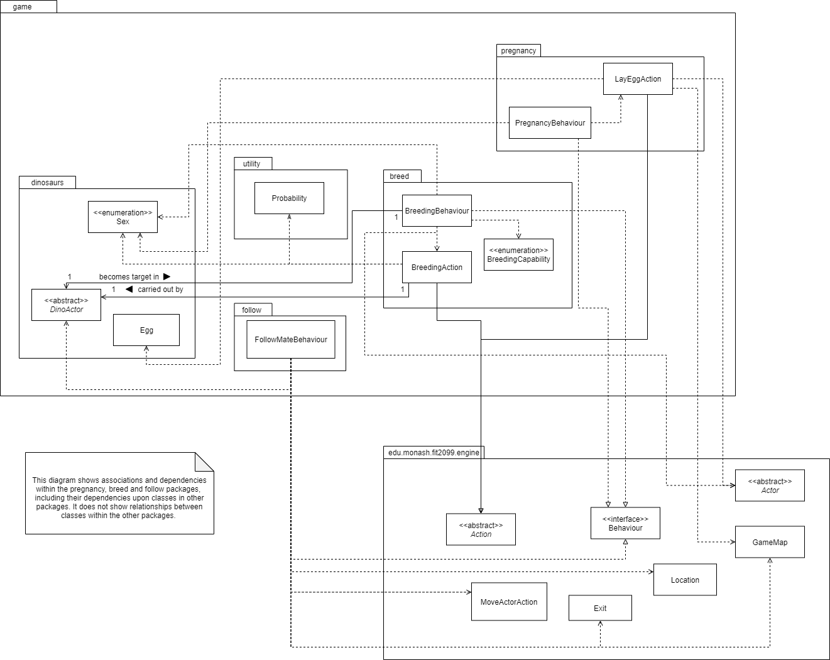

Class diagram – Player class, EcoPoints Class, FoodType class, actions package, environment package, vendingmachine package

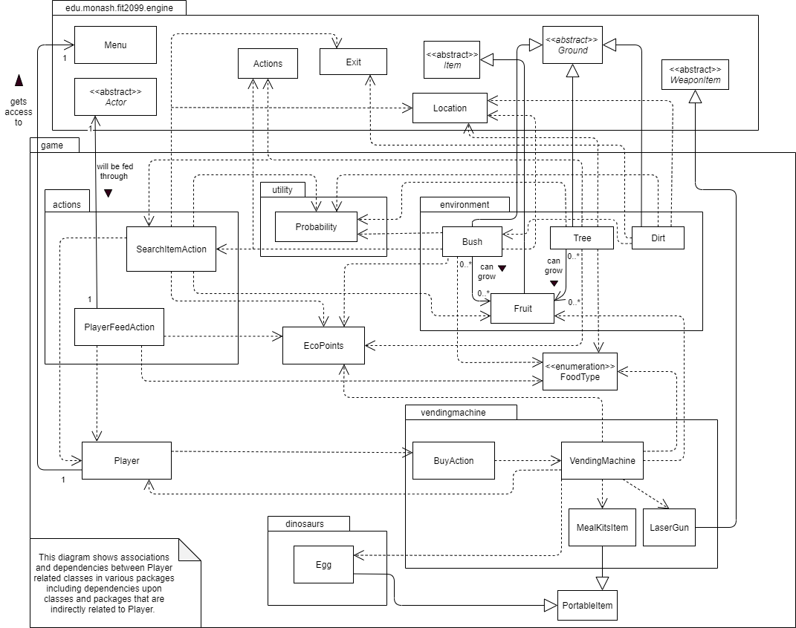

Class Diagram – attack package

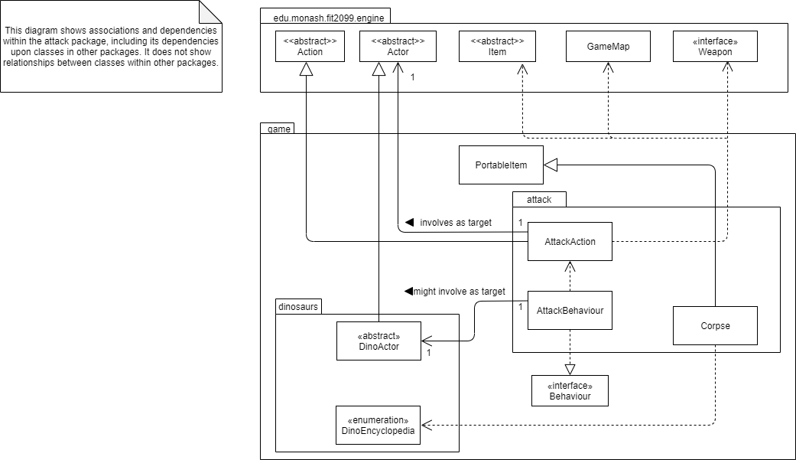

Class Diagram – feeding package

